Question 1.

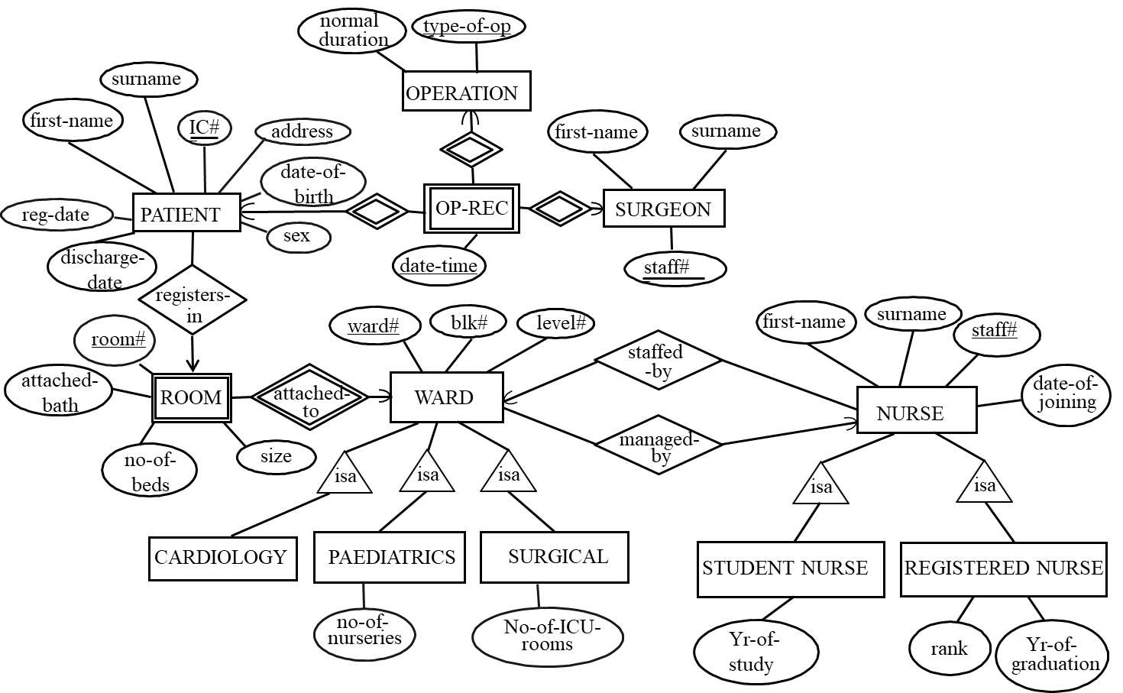

Question 2.

The following solution uses the NULL approach for subclasses:
- Patient (IC#, first-name, surname, address, date-of-birth, sex, reg-date, discharge-date, room#, ward#)
- Surgeon (surg-id, first-name, surname)
- Operation (type-of-op, normal-duration)
- Operate (IC#, surg-id, type-of-op, date-time)
- Room (room#, ward#, attached-bath, no-of-beds)
- Ward (ward#, blk#, level#, staff#, no-of-nurseries, no-of-ICU-rooms)
- Nurse (staff#, first-name, surname, date-of-joining, ward#, Yr-of-study, rank, yr-of-graduation)

